Infinite Cube

Infinite Cube

Idea: printing small toy that anyone can play with it to have fun. Simple toy easy to use and with no electric on it, in addition it help to release stress. In our Project, we chose to build up a constrictive toy using 3D printers. The toy’s shape is cubic. There would be 8 cubes in total to build up the toy. Each cube has two holes in two sides. The holes are to connect the parts together by inserting a metal or plastic stick to hold the cubes together. Each Stick or screw has a ranch in each end. The ranch help holds the stick in its place.
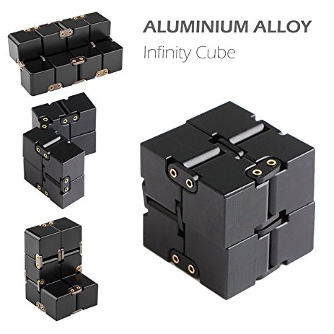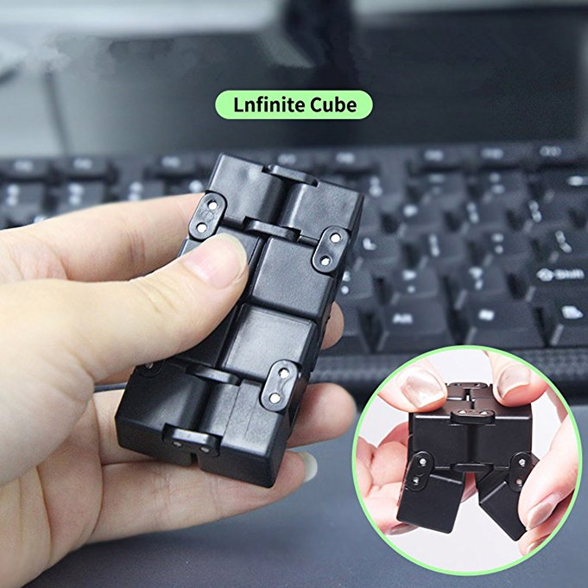

How to use:

The cube has 8 smaller individual cubes. Each one has 6 faces, also 48 small faces. When the cube is folded, 24 small faces will be seen, and 24 will be hidden. By folding you will see 3 rectangles consisting of 8 small faces every time you fold.
Infinite Cube help people whom trying to quit smoking, nail biting, leg shaking and all type of attention disorder problem .also , it help office worker and student to free their stress .

Designing Infinity Cube Fidget Toy took a long time to have it in the right shape, especially because we were trying to make it with the best quality that the 3D printer can print.
Printer: Anet A-8 3D Printer
Programs:
- Solidwork
- MasterCam
- Cora :to slice to object to make it ready to be printed by the printer
G-Code that has been used to print it with high quality:

Specifications

Material: 1.75MM PLA 3D FILAMENT PEAK GREEN-1KG (N.W.)
Print Temp: 205-225 C
Whole dimensions: 1.57*1.57*1.57 inch (4*4*4 cm)
Net Weight: 38.3 g
Gross weight: 54 g
Color: orang

Furthermore, we want the offset between all the pieces to be 0.25 mm for it to be able to move freely. The part changes face 3 times and in the process the final face would have FALL 2017.In the 4 cubes right below fall 2017 we would have the class name ENGR 4081.

The time to print:
30 min for each cubic multiply by 8 = 4 hours

Cost:
Filament cost: each =2m multiply by 4 =8m
1kilo = $20
Money that cost =100 gram multiply by 8 =800

We think that the printer does not need any change for now because it is perfect for the shape that we printed (Infinity Cube).

